Debugging using NetBeans

Programmers use debugging tools like NetBeans to help identify problems in a program and to easily fix the programs’ issue.

Breakpoints

• A point where the code will stop temporarily for user to analyze the code up till that point.
• To make a break point, click on the left side of the line. Upon doing so, a pink box will appear which would mean that a breakpoint has been made.
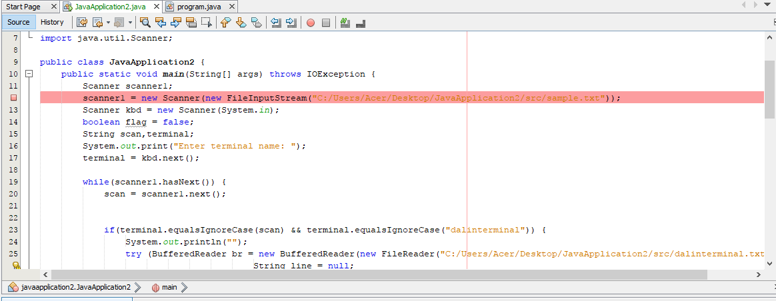

Start debugging session

• Click on the menu tab and then choose Debug and click on Debug file
• Once clicked on debug button its color will turn to green
• At the lower part a debugger console will appear where it will show the line breakpoint, the variables declared and other information to be used during the debugging session
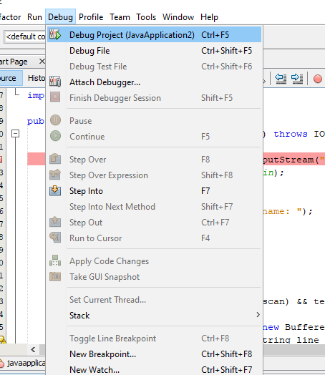

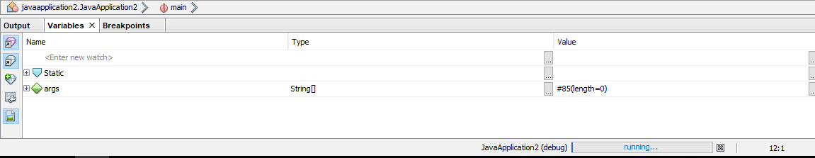

Step over(F8)

• Step over will view the input parameters and the resulting parameters then proceed to the next method
• Clicking on step over would change the color of the breakpoint and the next line would turn green
• The parameters of the next line would appear on the debugger console
